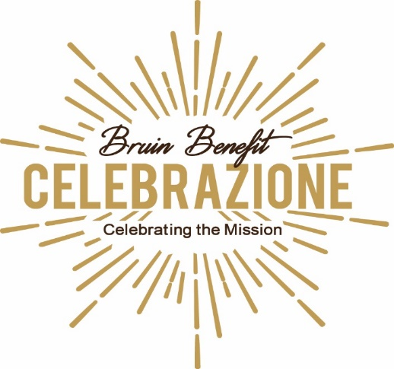

April 27, 2019 at Padua Franciscan High School

Celebrazione is Padua Franciscans’ biggest fundraising event and includes a full open bar,
dinner, live auction, silent auction, and more! All proceeds benefit Padua’s tuition assistance program.

SPONSORSHIP OPPORTUNITIES

___ $15,000 Platinum Title
Premium seating (2 tables of 10 guests) plus champagne toast / company logo displayed on mobile bidding app / logo featured at registration areas / full-page program ad on inside front cover, inside back cover or back cover / name on front cover of event program / acknowledgement during event

___ $10,000 Diamond
Premium seating (2 tables of 10 guests) plus champagne toast / company logo displayed on mobile bidding app / full-page program ad

___ $5,000 Gold
Preferred seating (1 table of 10 guests) / full-page program ad

___ $2,500 Silver
Preferred seating for 6 guests / ½ page program ad

___ $1,500 Bronze
Seating for 4 guests / ½ page program ad

___ $1,000 Patron
Seating for 2 guests

All sponsorships will receive recognition in event program, on website, and in the fall Paduan magazine.

Name:________________________________________________________________________________________
(as you want it to appear in the event program)

Phone Number:_____________________________________ Email: ______________________________________
- Make check payable to: Padua Franciscan High School
- Mail check to: Padua/Bruin Benefit 6740 State Road Parma, OH 44134
- Contact: Amy DiMarco ’91, Events Coordinator, 440-845-8224 or adimarco@paduafranciscan.com
Padua Franciscan High School is a non-profit institution, and your gift is greatly appreciated. Padua’s Federal Tax I.D. number is 34-1719465.

