In accordance with Padua Franciscan High School’s enhanced security measures, beginning Monday August 1, the login method to MyPad will be changing for all Parents.

The new security measures will require you to use the email address you registered with the school as the username for logging in to MyPad.

You will receive an email invitation from paduafranciscan@mychoolapp.com with an invitation to login via Blackbaud ID Services

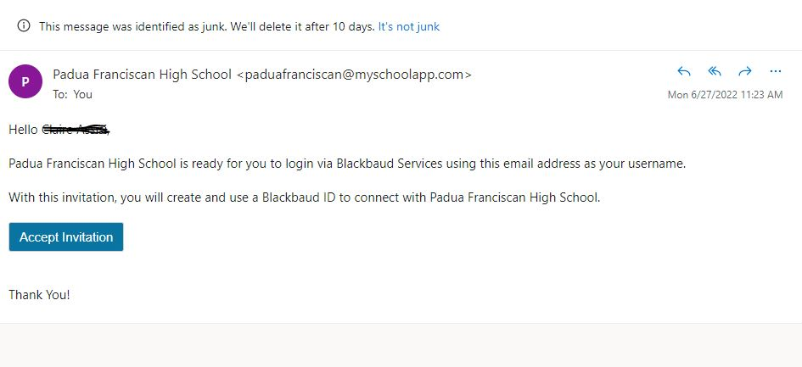

Click on Accept Invitation.

On the next screen it will ask for additional information to complete your Blackbaud ID sign-up. Fill all of the fields out. You MUST use the email address you registered with Padua previously.

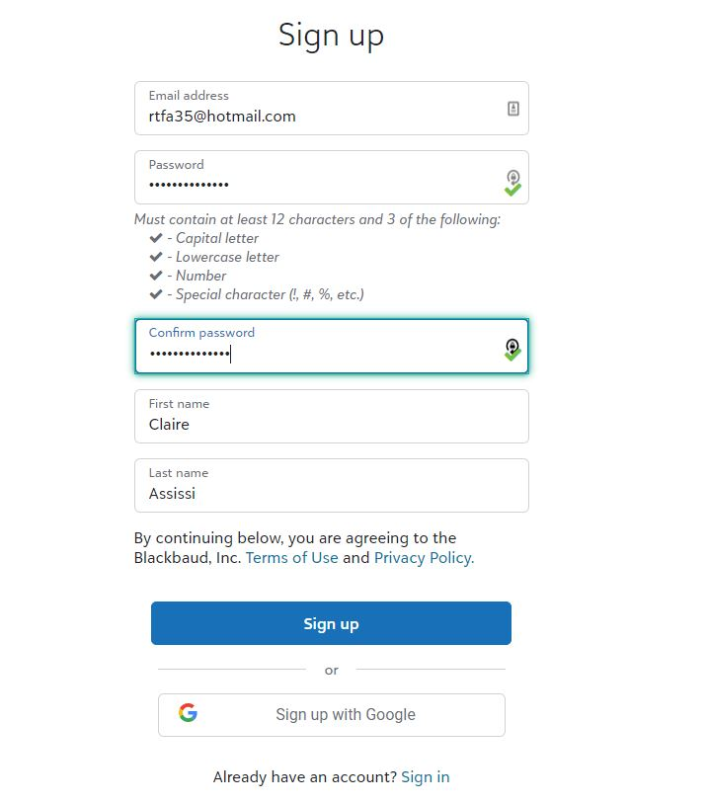

Click Sign Up when done

You should see an acknowledgement screen if successful. A confirmation email will be sent.

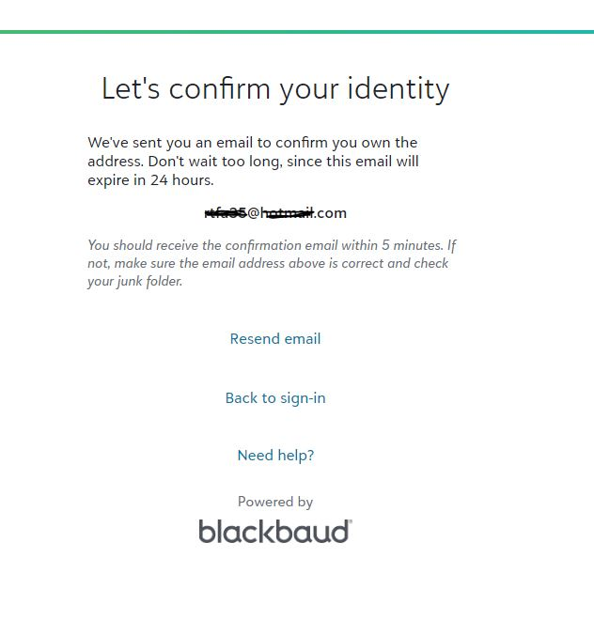

On the confirmation email click Confirm

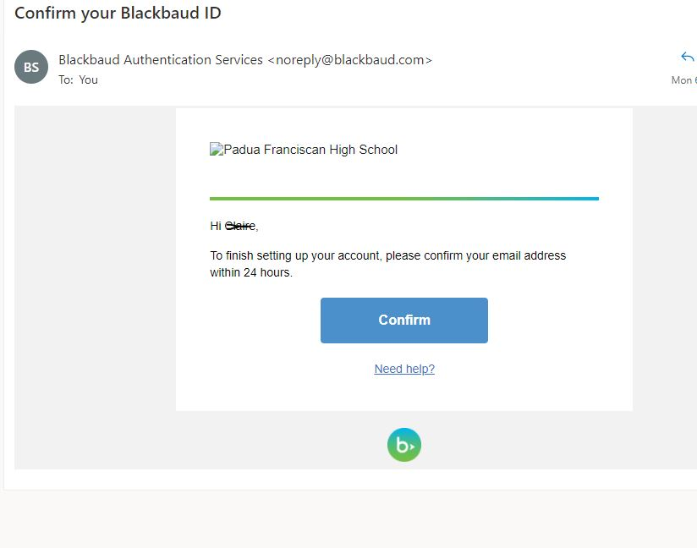

Your sign-up process is now complete. For any issues with sign-in, please email mypadhelp@paduafranciscan.net

