August 15th-19th | Monday  8/15/22 | Tuesday  8/16/22 | Wednesday  8/17/22 | Thursday  8/18/22 | Friday  8/19/22
 | Faculty & Staff | Faculty & Staff | Fiti Day:  Cheese Pizza or Pepperoni Pizza, Chips, Water | Chicken Strip Basket, French Fries, Celery, Carrots with Choice of Sauce | Bruin Big Read: Chicken Sandwich or Cheeseburger, Chips, Water
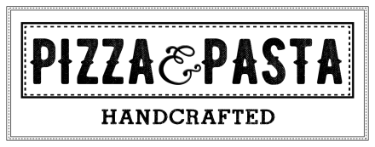 | Faculty & Staff | Faculty & Staff | Fiti Day:  Cheese Pizza or Pepperoni Pizza, Chips, Water | Cheese Pizza  Pepperoni Pizza  Meat lover’s Pizza | Bruin Big Read: Chicken Sandwich or Cheeseburger, Chips, Water
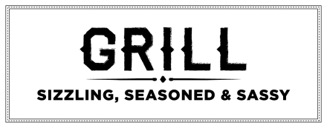 | Faculty & Staff | Faculty & Staff | Fiti Day:  Cheese Pizza or Pepperoni Pizza, Chips, Water | Hamburger  Cheeseburger  Chicken Sandwich  Buffalo Chicken Sandwich | Bruin Big Read: Chicken Sandwich or Cheeseburger, Chips, Water
 | Faculty & Staff | Faculty & Staff | Fiti Day:  Cheese Pizza or Pepperoni Pizza, Chips, Water | Chicken Noodle  Weekly Wrap:  Buffalo Chicken  Salad Bar | Bruin Big Read: Chicken Sandwich or Cheeseburger, Chips, Water
Lunches are available from 11:00am-1:00pm. Contact Serina Cleavenger at 440.845.2444x140 for questions or comments.
Padua High School
