MyPad Log In Changes
In accordance with Padua Franciscan High School’s enhanced security measures, beginning Monday August 1, the login method to MyPad will be changing for all Parents.

The new security measures will require you to use the email address you registered with the school as the username for logging in to MyPad.

- You will receive an email invitation from paduafranciscan@myschoolapp.com with an invitation to log in via Blackbaud ID Services. Check your spam/junk folders if the email does not appear in your inbox. It should look like the email below:

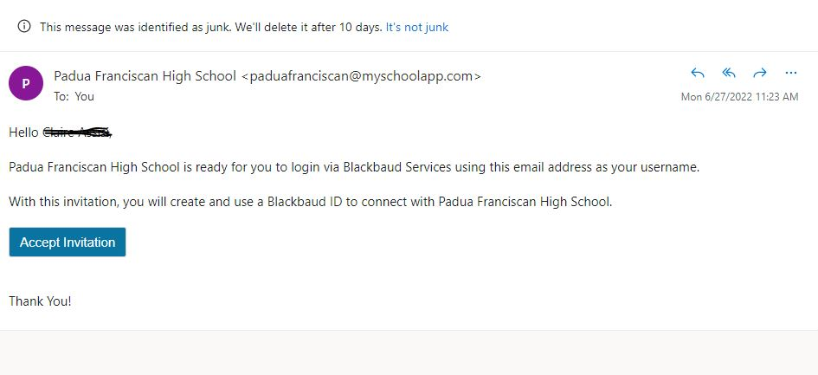

- Click on Accept Invitation.

- On the next screen it will ask for additional information to complete your Blackbaud ID sign-up. Fill all of the fields out. You MUST use the email address you registered with Padua previously. DO NOT click Sign up with Google. Create a password and complete the other fields. See the screen below as an example:

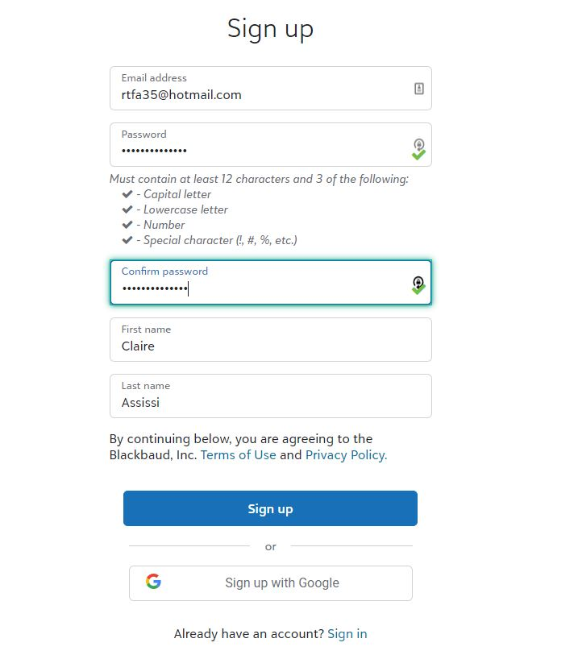

- Click Sign Up when done

- You should see an acknowledgement screen if successful. A confirmation email will be sent.

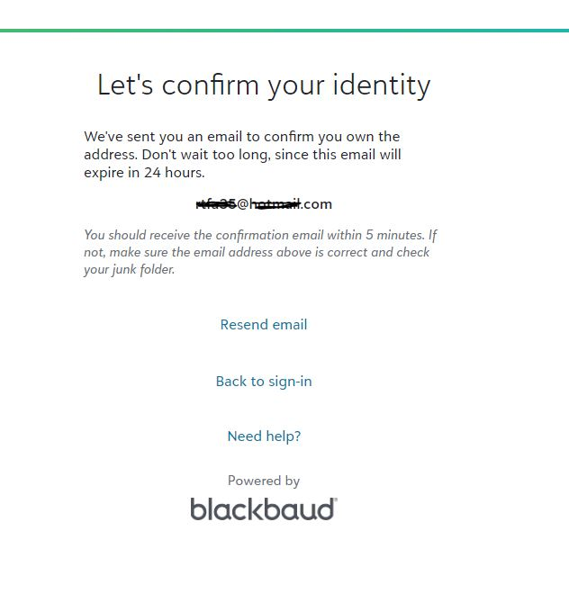
- Go into your email that was entered. The confirmation email should be there. Again, be sure to check spam/junk folders if you do not see it.

- In the confirmation email click Confirm.

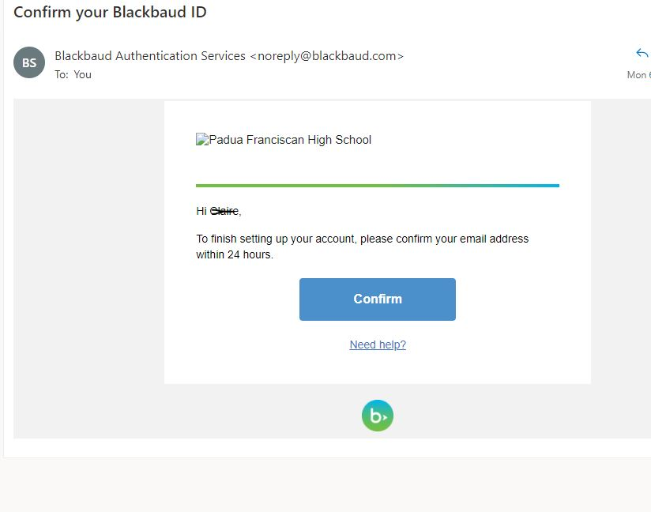

- Your sign-up process is now complete. For any issues with sign-in, please email mypadhelp@paduafranciscan.net

