August 29th-2rd | Monday  8/29/22 | Tuesday  8/30/22 | Wednesday  8/31/22 | Thursday  9/1/22 | Friday  9/2/22
 | Chicken Nugget Basket:  Chicken Nuggets with Choice of Sauce served with Buffalo Wedges | Loaded Nacho’s:  Tortilla Chips, Beef or Chicken, Nacho Cheese with Choice of Assorted Toppings | Wing Wednesday:  Boneless Wings served with Fries, Celery, Carrots & Ranch | Mac & Cheese Bar:  Five Cheese Mac and Cheese served with Choice of Toppings and Fresh Vegetables | Hot Dog Bar:  All American Beef Hot dog with Choice of Toppings and Loaded Fries
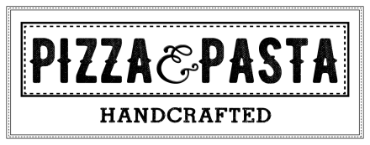 | Cheese Pizza  Pepperoni Pizza  Veggie Pizza | Cheese Pizza  Pepperoni Pizza  Meat Lover’s Pizza | Cheese Pizza  Pepperoni Pizza  BBQ Chicken Pizza | Cheese Pizza  Pepperoni Pizza  Loaded Potato Pizza | Cheese Pizza  Pepperoni Pizza  Pretzel Pizza’s
 | Hamburger  Cheeseburger  Chicken Sandwich  Meatball Sub | Hamburger  Cheeseburger  Chicken Sandwich  Philly Cheesesteak | Hamburger  Cheeseburger  Chicken Sandwich  Padua Mac | Hamburger  Cheeseburger  Chicken Sandwich  BBQ Bacon Chicken | Hamburger  Cheeseburger  Chicken Sandwich  Hot Italian Sub
 | Chicken & Rice  Weekly Wrap:  BBQ Chicken  Salad Bar | Spinach Tortellini  Weekly Wrap:  BBQ Chicken  Salad Bar | Potato & Sausage  Weekly Wrap:  BBQ Chicken  Salad Bar | Minestrone  Weekly Wrap:  BBQ Chicken  Salad Bar | Chicken Gnocchi  Weekly Wrap:  BBQ Chicken  Salad Bar
Lunches are available from 11:00am-1:00pm. Contact Serina Cleavenger at 440.845.2444x140 for questions or comments.
Padua High School

