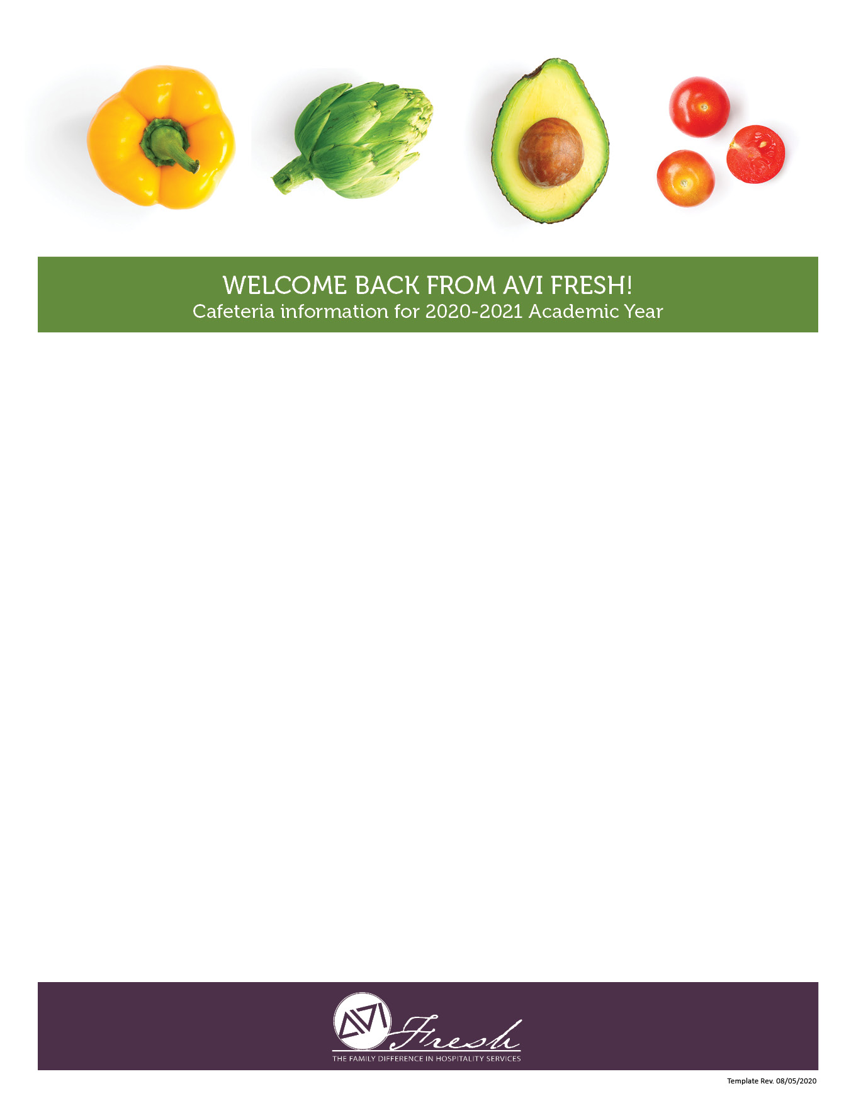
HELLO AGAIN FROM AVI FRESH!
The dining services team is excited to welcome you back as we start a new school year.
Our team is looking forward to your arrival and is honored to serve the students, faculty and staff
at Padua Franciscan High school

During summer break, we’ve been preparing new recipes and getting everything ready for back to school.
We have many exciting programs and menus planned!

Menus for your school are available on this page below
If you should have any questions or special requests regarding food sensitivities,
please contact us and we’ll be glad to work together.

We’re grateful for the opportunity to serve you!

SCHOOL LUNCH ACCOUNTS  We make purchasing school lunches easy and convenient.  Options include:  - Students may add Cash or Checks to their accounts between 7:30am-8:00am & 2:30pm-3:00pm.  - Online on your students PaySchools Account  - Please make Checks Payable to: AVI Foodsystems | A SPECIAL NOTE ABOUT COVID-19  Please rest assured AVI Fresh has partnered with the school to develop a comprehensive and strategic plan in response to the pandemic. As we navigate through these challenging times, AVI will continue working collaboratively with the school to ensure that appropriate changes to our service delivery and other operational aspects are managed with care and a strong commitment to your students and safety.
WE’RE HERE TO SERVE YOU!
Serina Cleavenger
Resident Director
Phone: 440.845.2444 x140 or
Email: Scleavenger@AVIFoodsystems.com

