September 19-23rd | Monday  9/19/22 | Tuesday  9/20/22 | Wednesday  9/21/22 | Thursday  9/22/22 | Friday  9/23/22
 | Bruin Bowl:  Mashed Potatoes, Fried Chicken, Corn, Gravy and Cheddar Cheese served with Biscuit | Chicken Fajita’s:  Flour Tortilla, Marinated Grilled Chicken, Onions & Peppers served with Fiesta Rice | Wing Wednesday:  Boneless Wings served with Fries, Celery, Carrots & Ranch | Sweet & Sour Chicken:  Chicken, Pineapple, Onions & Peppers served over Steamed Rice with Egg Roll and Fortune Cookie | Penne & Meatballs:  Penne Pasta with Meatballs in Homemade Marinara, served with Breadstick
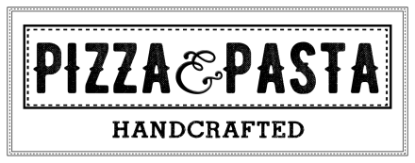 | Cheese Pizza  Pepperoni Pizza  Buffalo Chicken Pizza | Cheese Pizza  Pepperoni Pizza  Pepperoni & Sausage Pizza | Cheese Pizza  Pepperoni Pizza  Chicken Bacon Ranch Pizza | Cheese Pizza  Pepperoni Pizza  Bacon Lover’s Pizza | Cheese Pizza  Pepperoni Pizza  French Bread Pizza’s
 | Hamburger  Cheeseburger  Chicken Sandwich  Spicy Chicken Sandwich | Hamburger  Cheeseburger  Chicken Sandwich  Bacon Cheeseburger | Hamburger  Cheeseburger  Chicken Sandwich  Chicken Parmesan Sub | Hamburger  Cheeseburger  Chicken Sandwich  Italian Sausage Sandwich | Hamburger  Cheeseburger  Chicken Sandwich  Crispy Chicken Club Sandwich
 | Chicken Noodle  Weekly Wrap:  Buffalo Chicken  Salad Bar | Italian Wedding  Weekly Wrap:  Buffalo Chicken  Salad Bar | Loaded Potato  Weekly Wrap:  Buffalo Chicken  Salad Bar | Broccoli Cheddar  Weekly Wrap:  Buffalo Chicken  Salad Bar | Corn Chowder  Weekly Wrap:  Buffalo Chicken  Salad Bar
Lunches are available from 11:00am-1:00pm. Contact Serina Cleavenger at 440.845.2444x140 for questions or comments.
Padua High School

