September 5th-9th | Monday  9/5/22 | Tuesday  9/6/22 | Wednesday  9/7/22 | Thursday  9/8/22 | Friday  9/9/22
 | Labor Day | Walking Taco’s:  Doritos, Beef or Chicken, Cheddar Cheese with Choice of Assorted Toppings served with Fiesta Rice | Wing Wednesday:  Boneless Wings served with Fries, Celery, Carrots & Ranch | Orange Chicken:  Orange Chicken served over White Rice with Broccoli and Fortune Cookie | Tuscan Chicken: Pan seared Chicken with a Creamy Sundried Tomato Sauce, Mashed Potatoes and Fresh Vegetables
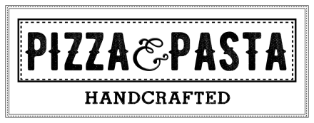 | Labor Day | Cheese Pizza  Pepperoni Pizza  Double Pepperoni | Cheese Pizza  Pepperoni Pizza  Chicken Bacon Ranch | Cheese Pizza  Pepperoni Pizza  Jalapeno Popper Pizza | Cheese Pizza  Pepperoni Pizza  Deluxe Pizza’s
 | Labor Day | Hamburger  Cheeseburger  Chicken Sandwich  Spicy Jalapeno Chicken | Hamburger  Cheeseburger  Chicken Sandwich  Rodeo Burger | Hamburger  Cheeseburger  Chicken Sandwich  Chicken Bacon Ranch | Hamburger  Cheeseburger  Chicken Sandwich  Deluxe Pizza Sub
 | Labor Day | Broccoli  Weekly Wrap:  Chicken Caesar  Salad Bar | Corn Chowder  Weekly Wrap:  Chicken Caesar  Salad Bar | Chicken Noodle  Weekly Wrap:  Chicken Caesar  Salad Bar | Zuppa Toscana  Weekly Wrap:  Chicken Caesar  Salad Bar
Lunches are available from 11:00am-1:00pm. Contact Serina Cleavenger at 440.845.2444x140 for questions or comments.
Padua High School

