September 12th-16th | Monday  9/12/22 | Tuesday  9/13/22 | Wednesday  9/14/22 | Thursday  9/15/22 | Friday  9/16/22
 | Chicken Fried Rice:  Chicken Fried Rice served with Eggroll, Stir Fried Vegetables and Fortune Cookie | Burrito Bowl:  Tortilla, Cilantro Lime Rice, with Choice of Marinated Grilled Chicken or Beef, Beans, Pico and Sour Cream | Wing Wednesday:  Boneless Wings served with Fries, Celery, Carrots & Ranch | Cranberry Stuffed Chicken:  Chicken Breast with a cranberry stuffing served with Roasted Potatoes and Vegetables | Italian Sausage Hoagie:  Italian Sausage with Choice of Onions & Peppers, Mozzarella Cheese served with Elephant Ear Fries
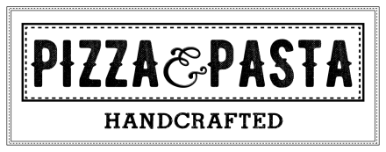 | Cheese Pizza  Pepperoni Pizza  Hawaiian Pizza | Cheese Pizza  Pepperoni Pizza  Caprese Pizza | Cheese Pizza  Pepperoni Pizza  Philly Cheesesteak Pizza | Cheese Pizza  Pepperoni Pizza  Grilled Chicken & Spinach Pizza | Cheese Pizza  Pepperoni Pizza  Italian Calzone
 | Hamburger  Cheeseburger  Chicken Sandwich  A1 Mushroom Swiss Burger | Hamburger  Cheeseburger  Chicken Sandwich  Grilled BLT | Hamburger  Cheeseburger  Chicken Sandwich  Chicken Bacon Swiss | Hamburger  Cheeseburger  Chicken Sandwich  Chicken Philly Sandwich | Hamburger  Cheeseburger  Chicken Sandwich  Monte Cristo
 | Chicken & Rice  Weekly Wrap:  Turkey Club  Salad Bar | Mushroom Soup  Weekly Wrap:  Turkey Club  Salad Bar | Vegetable  Weekly Wrap:  Turkey Club  Salad Bar | Chicken Pot Pie  Weekly Wrap:  Turkey Club  Salad Bar | Beef Barley  Weekly Wrap:  Turkey Club  Salad Bar
Lunches are available from 11:00am-1:00pm. Contact Serina Cleavenger at 440.845.2444x140 for questions or comments.
Padua High School

