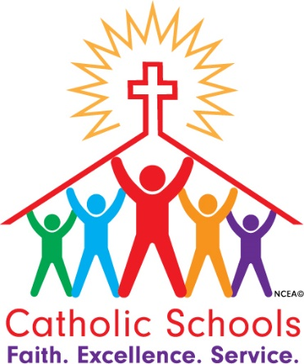
Catholic Schools Week
January 30 – February 3, 2023
Calendar

Catholic Schools Week is celebrated annually by all Catholic schools in the country. It is a time to celebrate what is unique about Catholic schools. We also celebrate all the people who make Catholic schools possible – teachers, staff, parents, students, donors. Below is the calendar of events at Padua during Catholic Schools Week.

Every Day
- A prayer will be publicly proclaimed inviting the Padua family to thank God for all those who make Catholic schools possible.
- On the Bruin Broadcast Network, students will explain how they live out the 4 Franciscan pillars at Padua Franciscan High School.

Monday, January 30
- The Bruin Broadcast Network team will broadcast a video in which teachers, staff, and students respond to the question: “What do you like most about being in a Catholic school?”
- “Why I am grateful for Catholic schools” banner will be available in the cafeteria during all lunches for everyone to add a thought, feeling, or experience.

Tuesday, January 31
- “Why I am grateful for Catholic schools” banner will be available in the cafeteria during all lunches for everyone to add a thought, feeling, or experience.

Wednesday, February 1
- Ice cream treat will be served at all lunches.

Thursday, February 2
- Friar Johnpaul will celebrate a special Catholic Schools Week Mass from 7:30am to 7:50am in the Campus Ministry Center. Parents, faculty, staff, and students are welcome.

Friday, February 3
- All faculty, staff and students all will have a Spirit dress down day.
- An appreciation lunch from Honey Baked Ham will be provided for faculty and staff.

