February 6th-10th | Monday  2/6/23 | Tuesday  2/7/23 | Wednesday  2/8/23 | Thursday  2/9/23 | Friday  2/10/23
 | Bruin Bowl:  Mashed Potatoes, Crispy Chicken, Corn, Gravy and Cheddar served with Biscuit | Loaded Nacho’s:  Choice of Beef or Chicken, Nacho Cheese and Choice of Toppings | Wing Wednesday:  Boneless Wings served with Fries, Celery, Carrots & Ranch | Orange Chicken:  Orange Chicken served over Vegetable Lo Mein with Fortune Cookie | Pierogi Bar:  Potato & Cheddar Pierogi’s served with Choice of Toppings and Vegetables
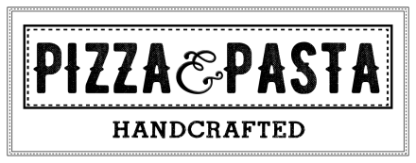 | Cheese Pizza  Pepperoni Pizza  Stuffed Pretzel | Cheese Pizza  Pepperoni Pizza  Jalapeno Chicken & Bacon | Cheese Pizza  Pepperoni Pizza  Pickle Pizza | Cheese Pizza  Pepperoni Pizza  Gyro Pizza | Cheese Pizza  Pepperoni Pizza  Sausage & Pepperoni Calzone
 | Hamburger  Cheeseburger  Chicken Sandwich  Buffalo Chicken | Hamburger  Cheeseburger  Chicken Sandwich  A1 Philly Sub | Hamburger  Cheeseburger  Chicken Sandwich  Ultimate Meatball Sub | Hamburger  Cheeseburger  Chicken Sandwich  Farmers Burger | Hamburger  Cheeseburger  Chicken Sandwich  Hot Italian
 | Chicken Noodle  Weekly Wrap:  Buffalo Chicken  Salad Bar | Potato & Kielbasa  Weekly Wrap:  Buffalo Chicken  Salad Bar | Vegetable Soup  Weekly Wrap:  Buffalo Chicken  Salad Bar | Mushroom Soup  Weekly Wrap:  Buffalo Chicken  Salad Bar | Chef’s Choice  Weekly Wrap:  Buffalo Chicken  Salad Bar
Lunches are available from 11:00am-1:00pm. Contact Serina Cleavenger at 440.845.2444x140 for questions or comments.
Padua High School

