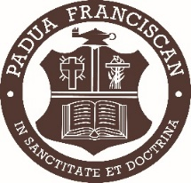****

**Thank you!**

*Padua High School gratefully acknowledges your generous donation. We reserve the right to auction or otherwise sell donated items in the manner we feel will maximize contributions to the school.* Padua is a non-profit institution. Tax ID# 34-1719465

**Deadline to be listed in the event program and ensure your donation is used in the auction is April 5, 2024.**

Please contact Amy DiMarco ’91 at [adimarco@paduafranciscan.net](mailto:adimarco@paduafranciscan.net) or 440-845-8224 with questions.

**Padua Franciscan High School 6740 State Rd. Parma, Ohio 44134**

$

**Item Retail Value**

**Description**

____ I will deliver my donation to Padua or ____ Please pick up my donation. It will be ready by:____________

**DONATION *Please provide a detailed description of the item(s).***

**Saturday, April 27, 2024 OFFICIAL DONATION FORM**

**DONOR INFORMATION**

**Donor Name (as it should appear in print)**

**Contact Name/Title**

**Address City State Zip**

**Phone Number E-mail Address**